Aia Al-Qasab

T5616SN

Advanced Enterprise Server Environment

Lab 2

**Lab 2. Hyper-V Virtual Machine Migration and Replication**

February 2019



**Lab 2. Hyper-V Virtual Machine Migration and Replication**

**Step 1. Prepare the servers and configure virtual networking**

* Start **WinServer-DC** and **wait for the log in screen to appear** (no need to login, the server is just needed to provide the domain authentication for the other computers) before starting the other VMs

- Start **WinServer-01** and **WinServer-02**

- Log in to **WinServer-01** as **MAMKLAB\Administrator** / **P@ssw0rd** (not the local admin!)

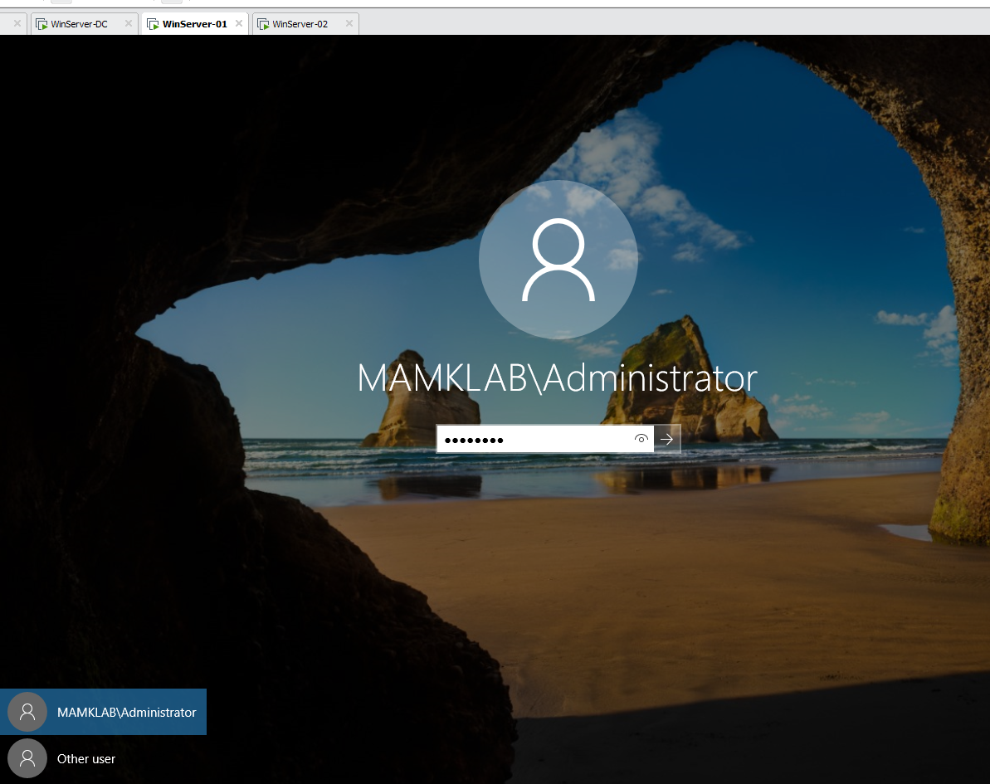

o If the network is recognized as a new network, and you get a question “*Do you want to find PCs, …*”, select **YES**

- Both servers already have the **Hyper-V** role installed

- In **WinServer-01**, open **Hyper-V Manager**, right-click “**Hyper-V Manager**” in the left pane, and select **Connect to server**…

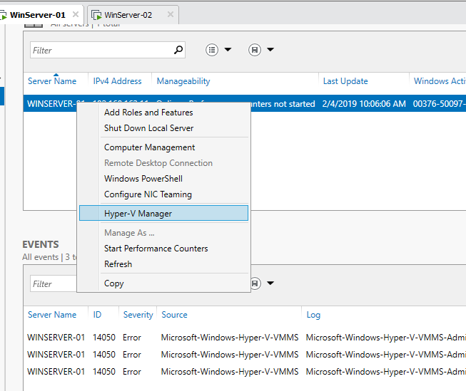

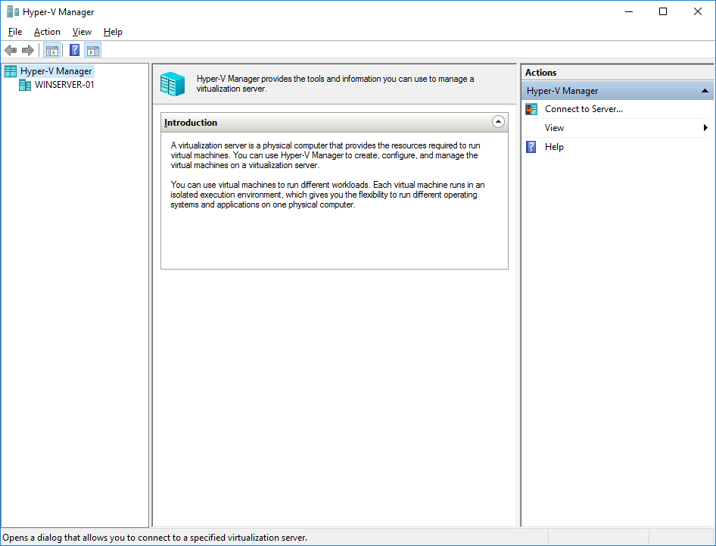

o Add a connection to **WinServer-02**

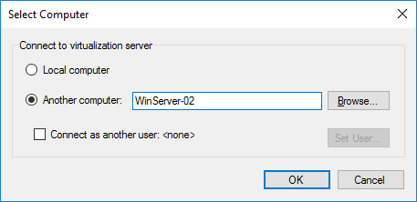

o Now you have two Hyper-V virtualization servers connected to the Hyper-V Manager tool in WinServer-01

- In **WinServer-01**, in **Virtual Switch Manager** change the **vSwitch** type to an **external virtual network switch**. Because the server network adapters are configured as a team, you need to use the **Microsoft Network Adapter Multiplexor Driver**.

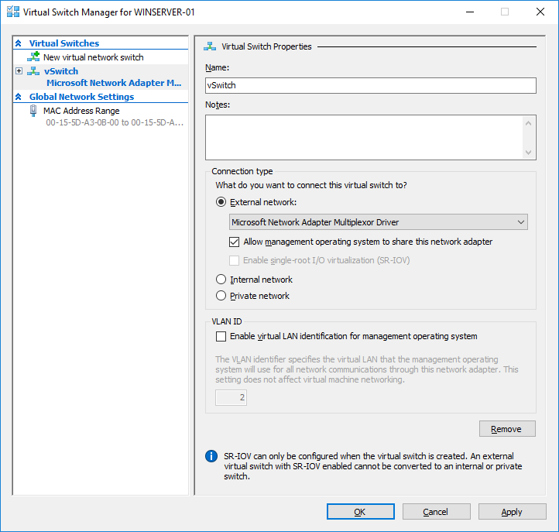

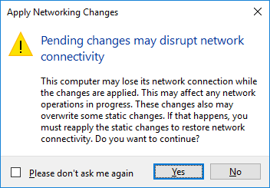

o Configure the virtual switch similarly in **WinServer-02** (do the configuration from the **WinServer-01** Hyper-V Manager)

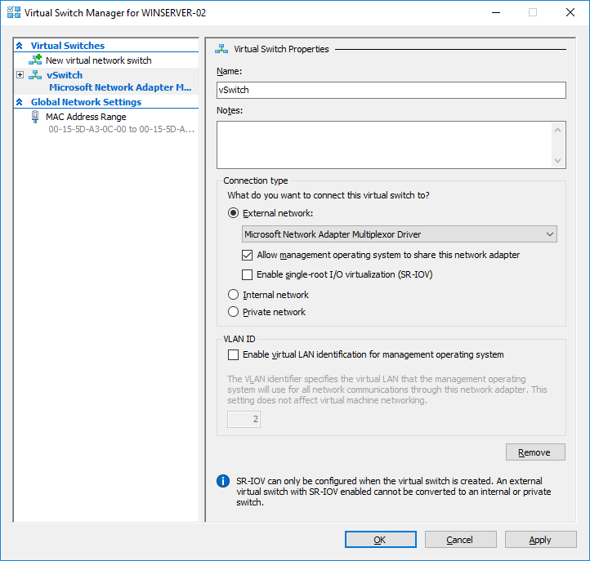



**Step 2. Importing and exporting virtual machines**

- In **WinServer-01**, open Windows File Explorer and unzip the ElementaryOS.zip file from P:\Matti\Hyper-V VMs to C:\Hyper-V. (use the **Student** / **student** account)

o In case you have trouble connecting to the P-drive, you can use the server’s name (\\mb3) or it’s IP (\\172.16.1.30).

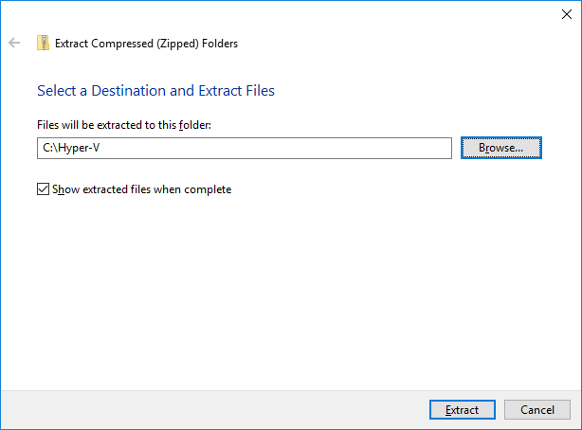

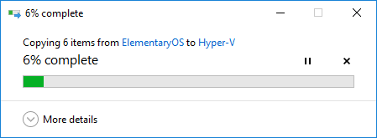

In **Hyper-V Manager**, **import** the existing virtual machine with the following settings:

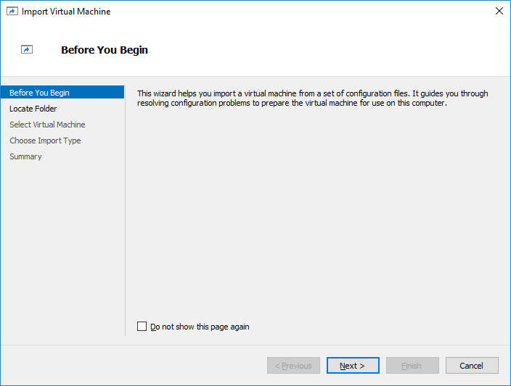

o Locate folder: C:\Hyper-V\ElementaryOS

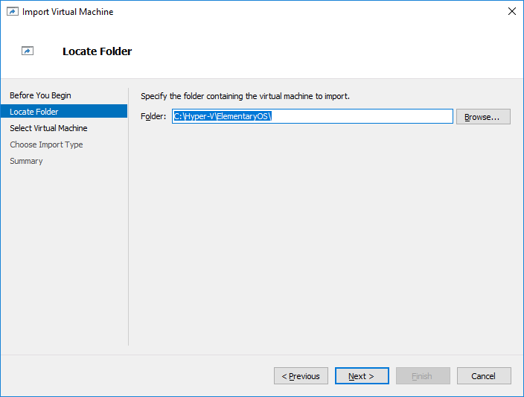

o Select the VM **ElementaryOS**

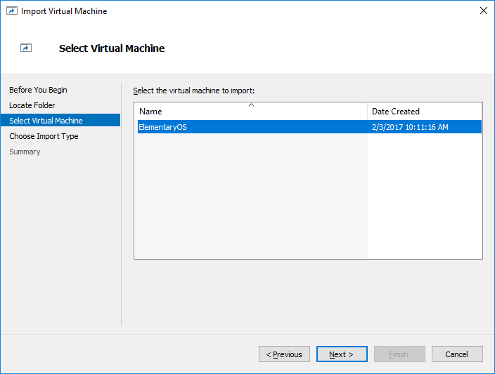

o Import type: **Register the virtual machine in-place (use the existing unique ID)**

▪ *When importing virtual machines, you need to select the import type:*

• *Register the virtual machine in-place (use the existing unique ID)*

• Restore the virtual machine (use the existing unique ID)

• Copy the virtual machine (create a new unique ID)

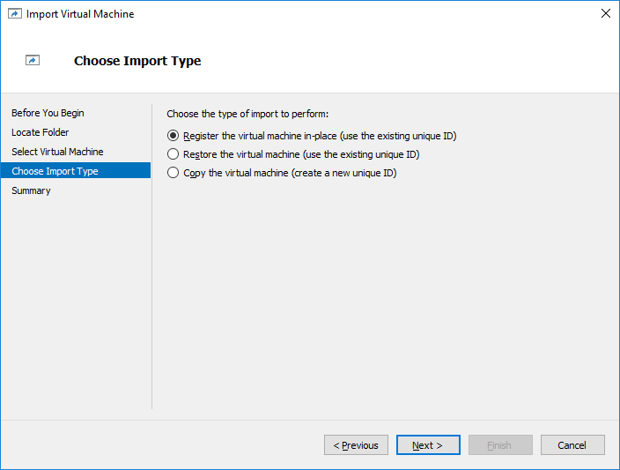

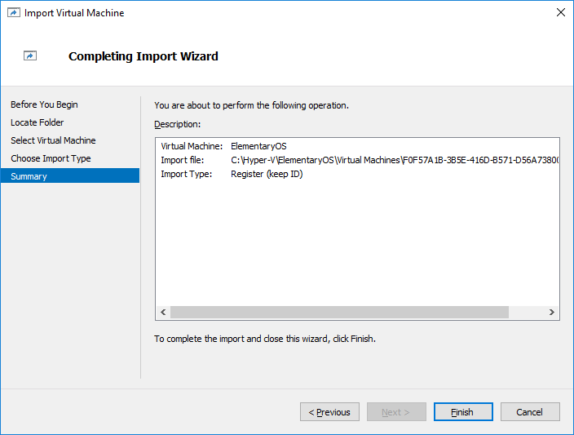

▪ *In* ***your report****, explain what these import types mean and how they are related to the virtual machine ID.*

**A: Register: The current location of the exports files where the virtual machines will be run from. When import, the virtual machines has the same ID as it did at the time of export. The VM is already registered with Hyper-V it needs to be deleted before the import will work.**

**Restore: It’s a given option to store the VM files in a specific location or use the locations default to Hyper-V, this import type creates a copy of the exported file and moves them to the selected locations.**

**Copy: This import type is similar to the Restore type in the selected location for the VM files, the difference is that when imported the VM has a new unique ID it allows for the VM to be imported into the same host multiple time.**

o Connect the virtual machine to the **vSwitch** to give it access to the network

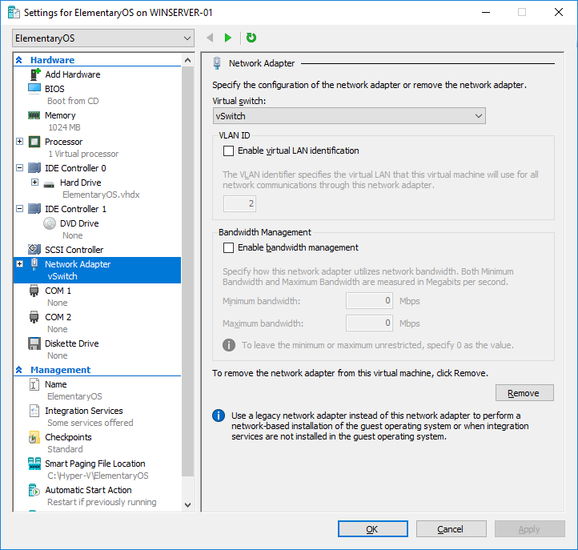

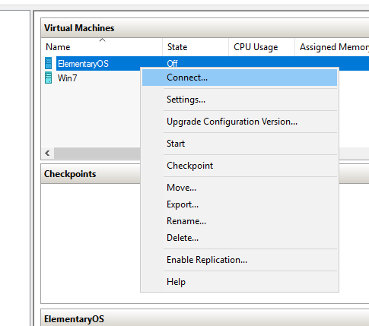

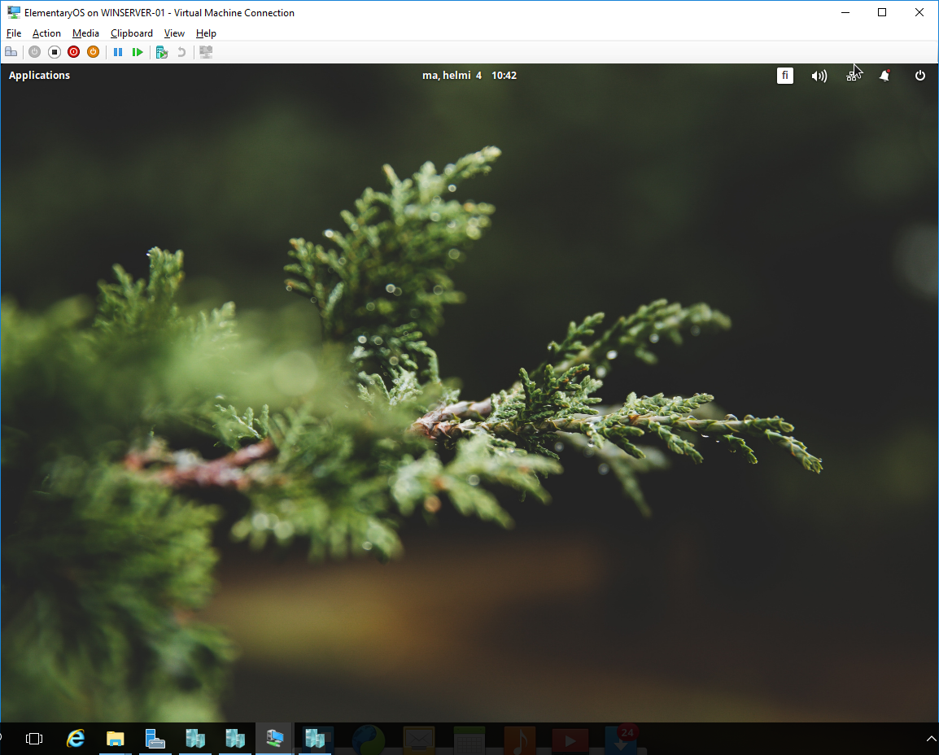

- Repeat the previous steps and import also the **DamnSmallLinux** VM



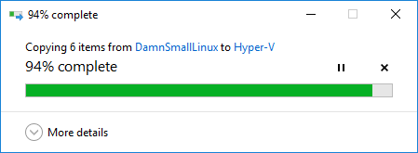

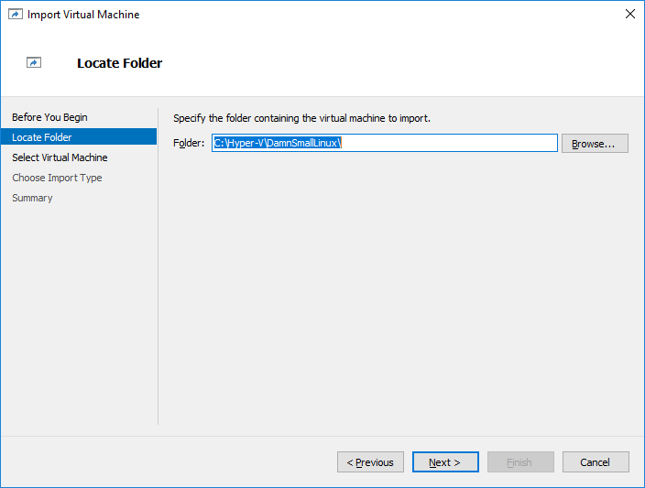

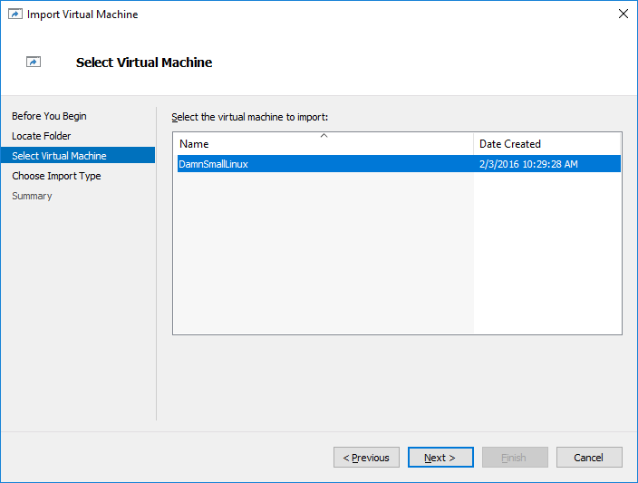



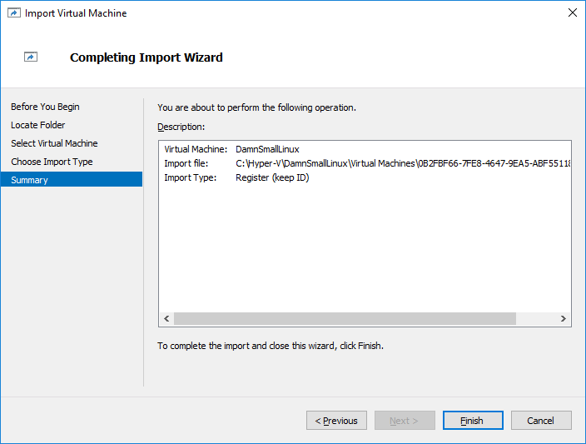

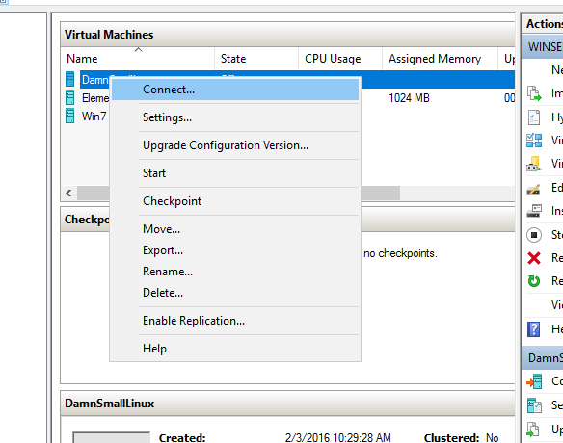

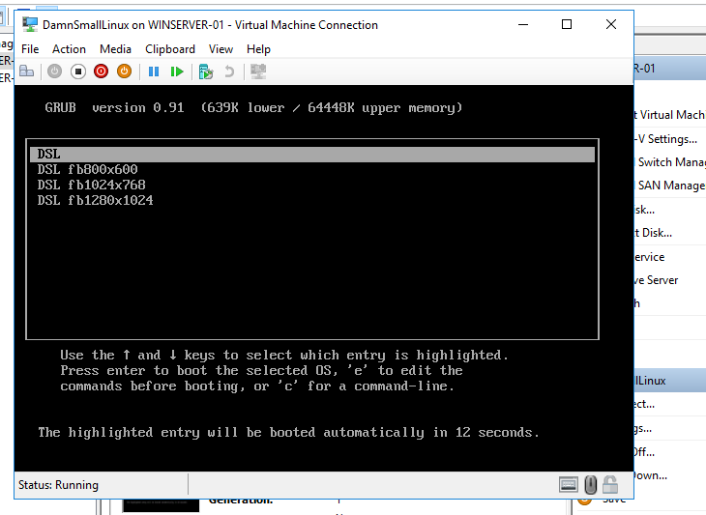

- Also practice **exporting** the virtual machine (this time in PowerShell)

o In PowerShell, export the **DamnSmallLinux** VM to the C:\Exports folder (create the folder, if needed)

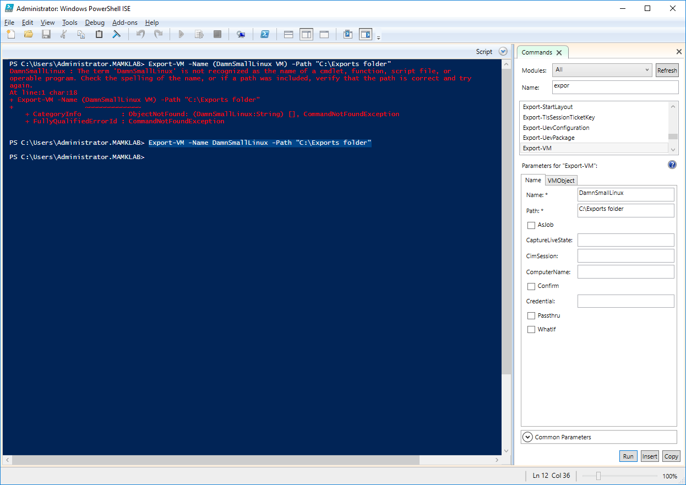

o *Copy-paste the used command(s)* ***and*** *their output to* ***your report****.*

Export-VM -Name DamnSmallLinux -Path "C:\Exports folder"

**Step 3. Migrating (moving) virtual machine between servers**

- Enable virtual machine migrations on **both** WinServer-01 and WinServer-02

o In **WinServer-01 Hyper-V Manager**, open the **Hyper-V Settings** and **Enable incoming and outgoing live migrations**

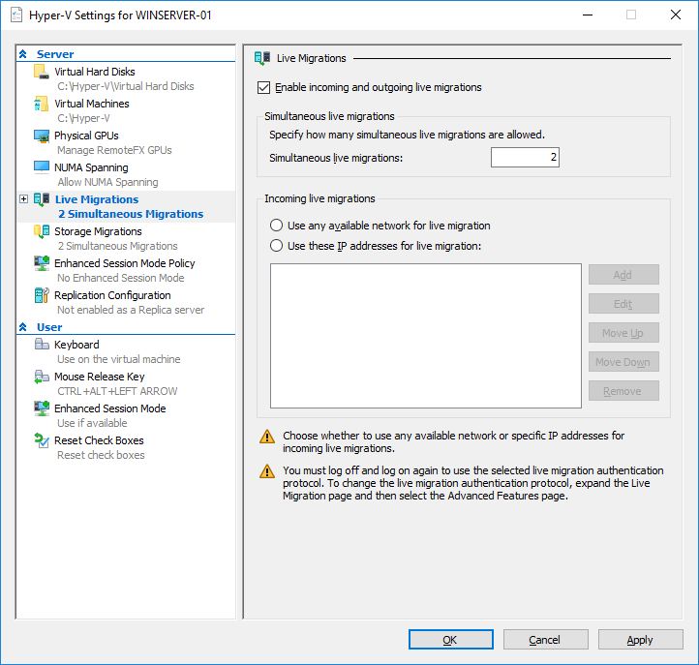

o Select **use any available network for live migration**

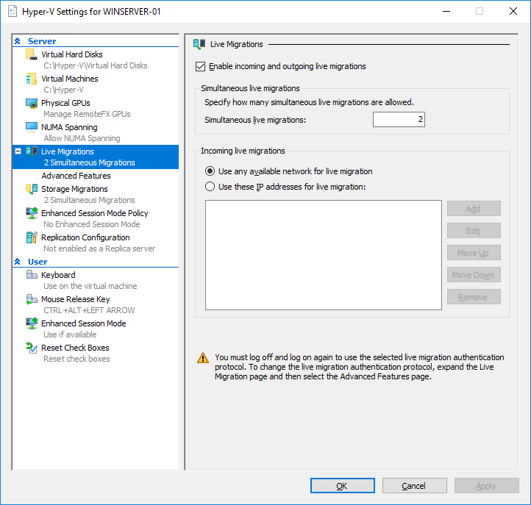

o Notice the warning saying that *you have to log off and log on again* to enable the protocol.

o Also check the **Advanced Features** on the Live Migrations: **compression** is on by default, which speeds up the migrations

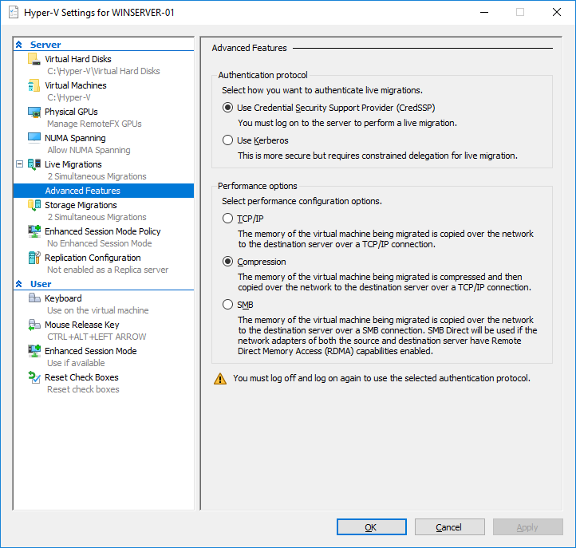

o Repeat the above process to **WinServer-02** (you can do it directly in the **WinServer-01** Hyper-V Manager!)

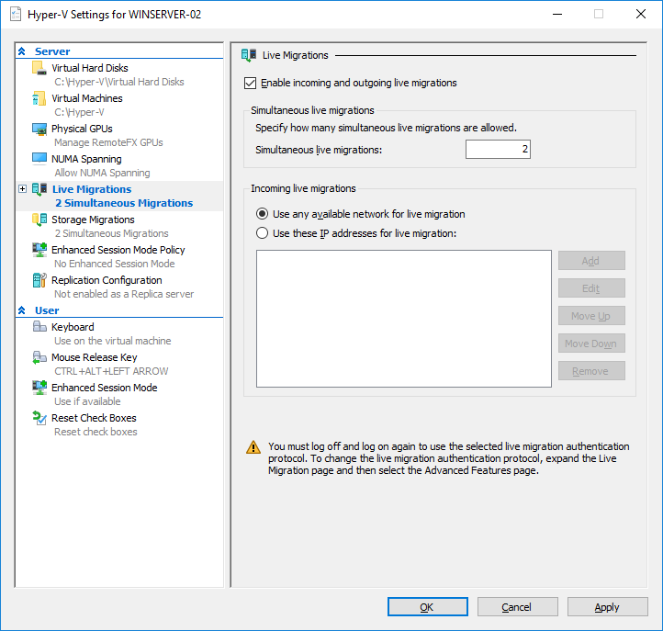

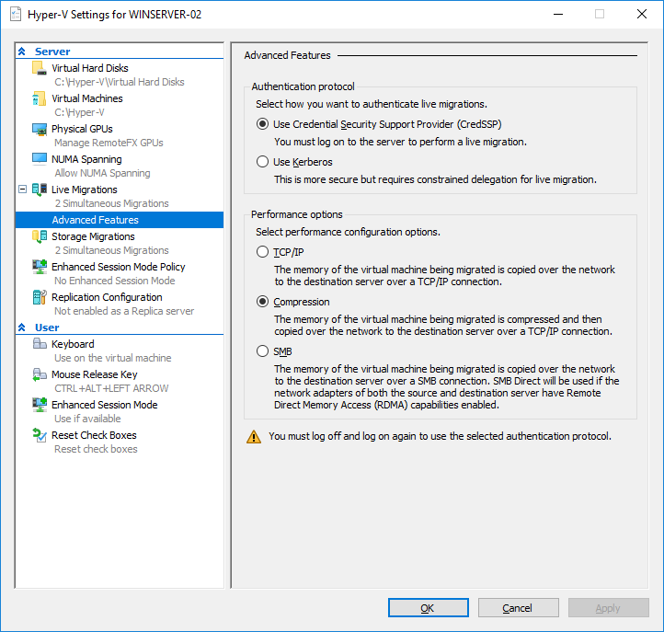

- Sign out from **WinServer-01** and login again as **MAMKLAB\Administrator**

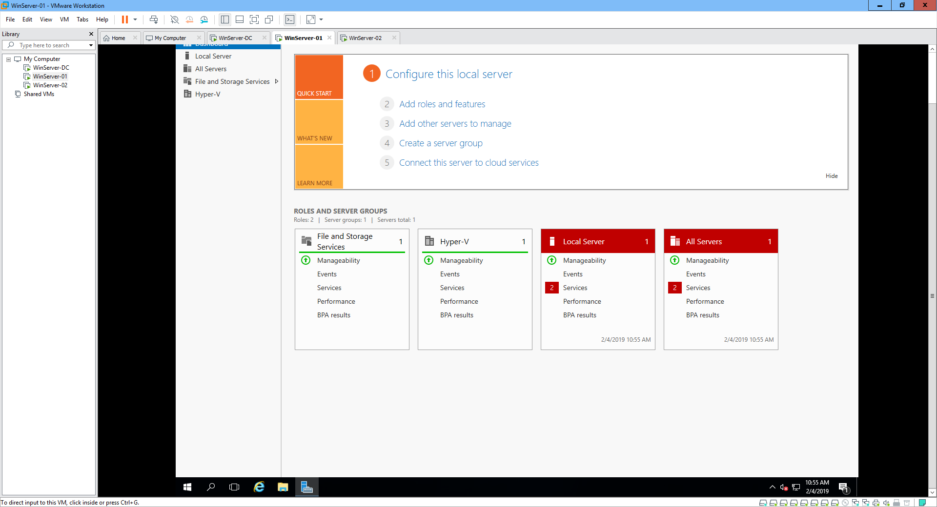

- Also login to **WinServer-02** as **MAMKLAB\Administrator**

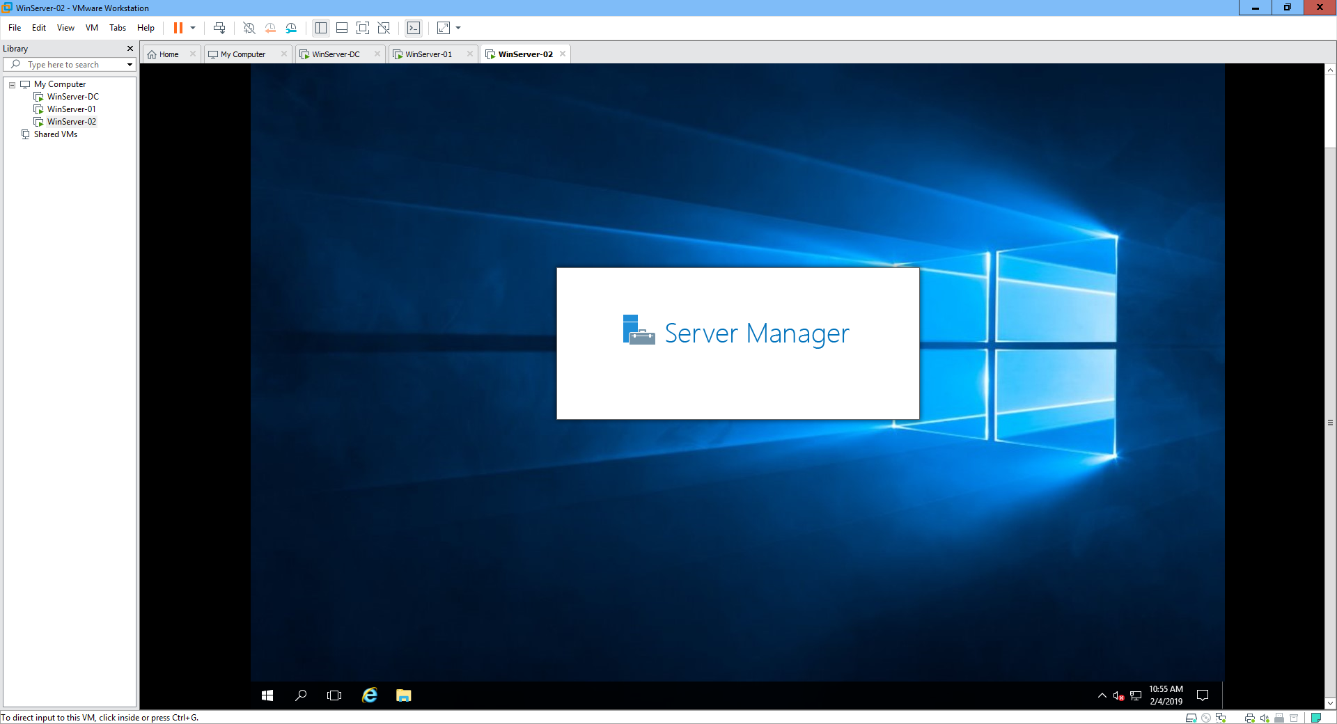

- In **WinServer-01**, connect to the **ElementaryOS** VM and power it on

o Login as **student** / **student** (if you are prompted to login)

o Start pinging some network destination (for example www.google.fi)

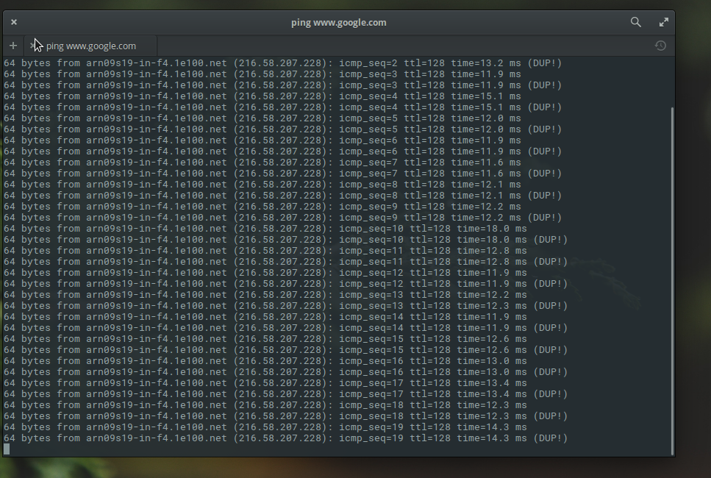

- Move (migrate) the **ElementaryOS** VM (the whole VM, including its storage) to **WinServer-02**

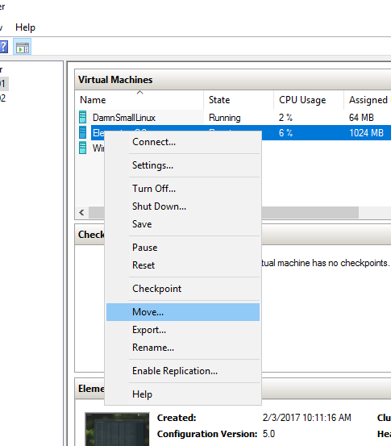

o Select to **Move the virtual machine’s data to a single location**

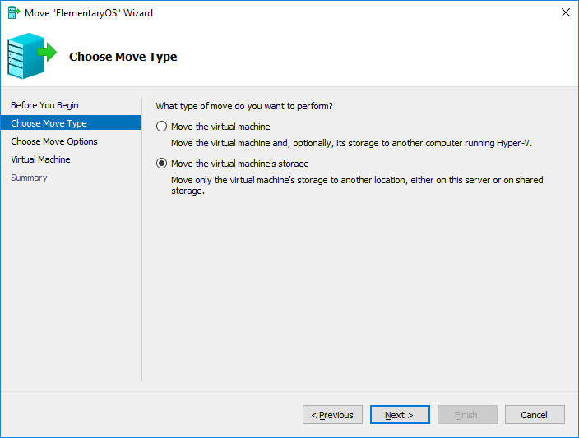

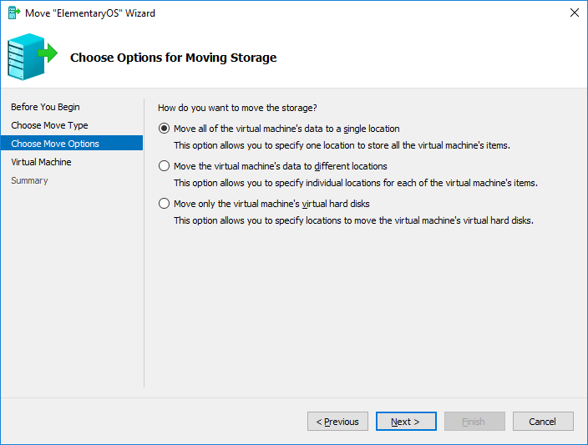

o Select C:\Hyper-V as the destination location

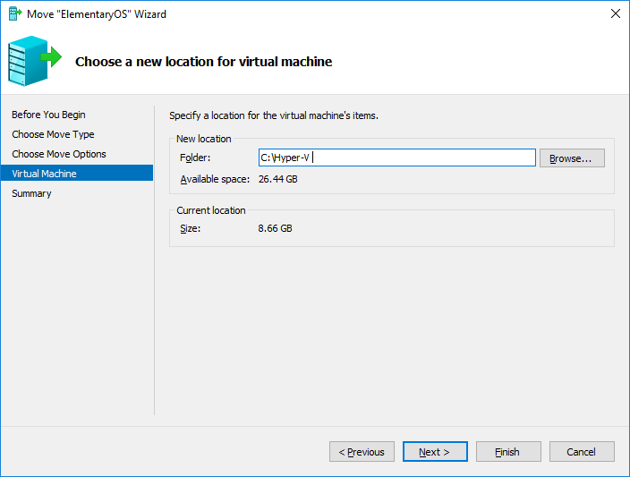

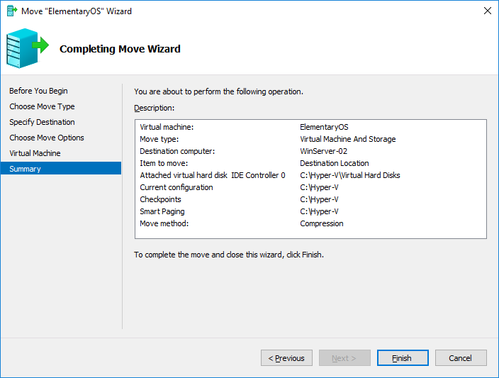

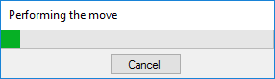

o (if you get an error message about authentication, you can try using Kerberos authentication instead of CredSSP (from the Hyper-V Settings → Live Migrations → Advanced Features))

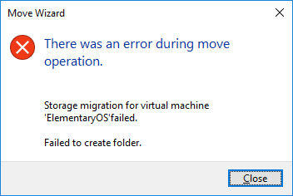

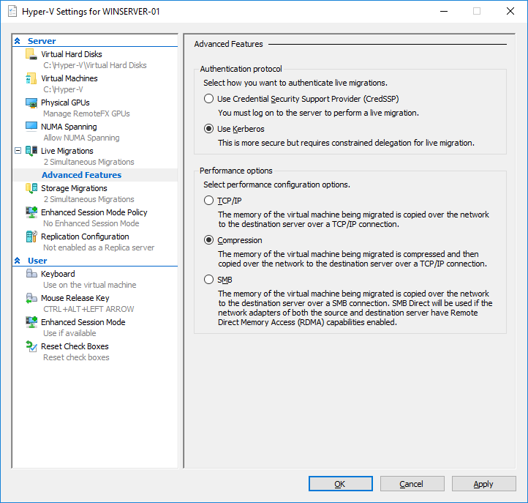

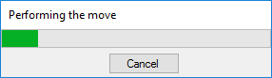

- While the move is being performed, ensure from the **ElementaryOS** connection that the virtual machine is running correctly, can be used normally and the pings are working

o Extend the **Status** column in the Hyper-V Manager to see the migration percentage

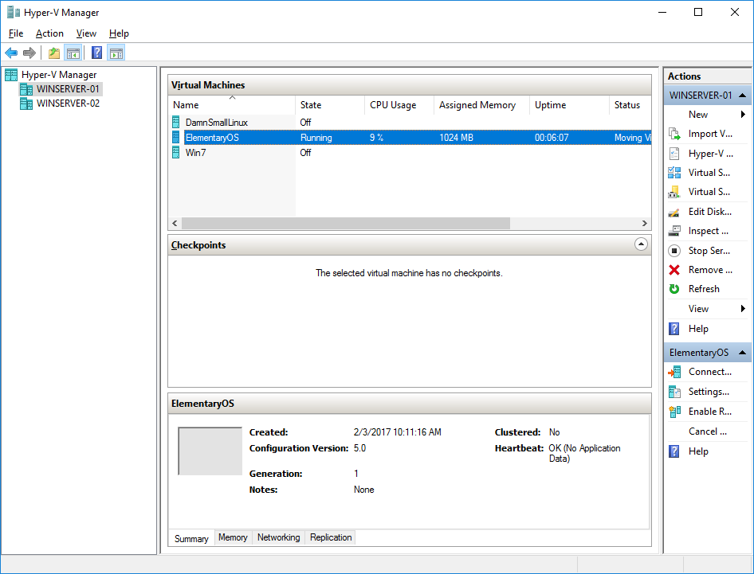

o *In* ***your report****, explain in steps and in detail, how exactly does the* ***live migration*** *process work in practice. What exactly is moved and in which order? How is it possible to move the virtual hard disk while it is in use (how are the reads and writes handled in practice)? How about the RAM; how is it possible to move also the RAM contents between the servers (while the VM is running and RAM is being used)?*

**A: Live migration takes place between two Hyper-V hosts, the VM memory is copied between Hyper-V hosts. After the memory is copied, the VM on the new host can access its virtual hard disk files and continue to run, both hosts access shared storage where the VM’s VHD files are stored.**

**1. A new VM configuration file is created on the target server.**

**2. The source VM’s initial memory state is copied to the target.**

**3. Changed memory pages on the source VM are tagged and copied to the target.**

**4. This process continues until the number of changed pages is small.**

**5. The VM is paused on the source node.**

**6. The final memory state is copied from the source VM to the target.**

**7. The VM is resumed on the target.**

**8. An Address Resolution Protocol (ARP) is issued to update the network routing tables.**

- Now test migrating a VM also **in the PowerShell**

o You can do this while the **ElementaryOS** VM is being migrated, no need to wait

o The **DamnSmallLinux** VM can be running or turned off, do however you wish…

o Open the **PowerShell**

o Check the current VM information with **Get-VM** (you can see the **ElementaryOS** is being migrated, in case the migration process is not yet completed)

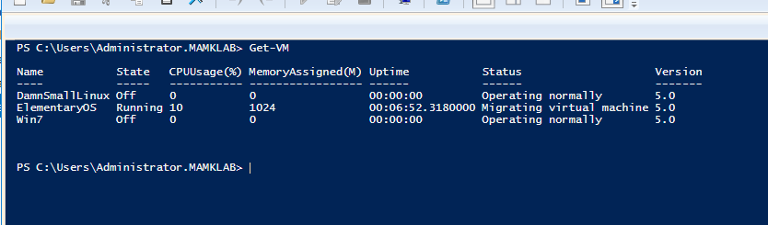

o Migrate the **DamnSmallLinux** from **WinServer-01** to **WinServer-02**

▪ Just like before, use C:\Hyper-V as the destination location

▪ Remember to also migrate the storage



  

▪ *Copy-paste the command(s) you used to* ***your report****.*

Move-VM -DestinationHost WinServer-02 -Name DamnSmallLinux -DestinationStoragePath C:\Hyper-V -IncludeStorage

o When the migration is complete, check with Get-VM that the VM is no longer in **WinServer-01**

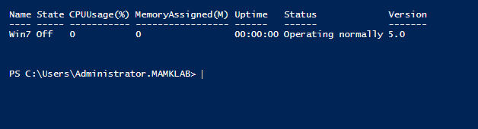

- Also check in **Hyper-V Manager** that the VM is no longer located in WinServer-01 (maybe also the **ElementaryOS** migration is ready)

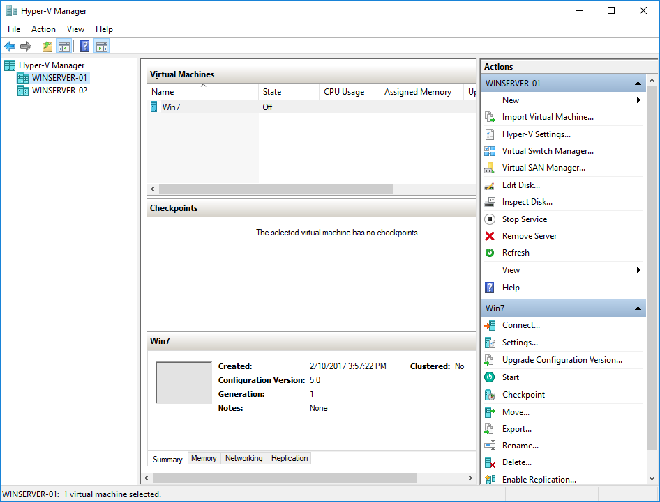

- Select **WinServer-02** from the **Hyper-V Manager** and ensure the VMs are successfully moved to **WinServer-02**

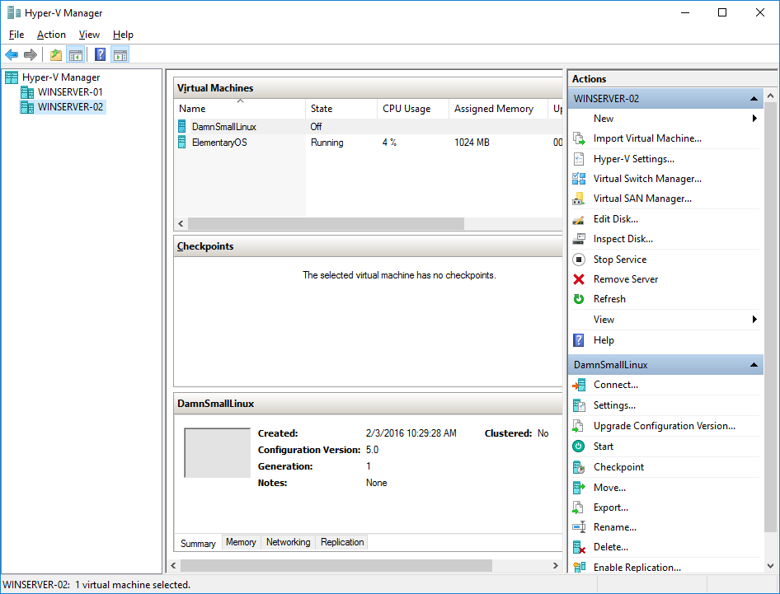

- Ensure that the connection to both VMs still works (from **WinServer-01**) even if they are running on a different server – notice that you can connect to the VMs remotely, no need to use the server/computer where the VMs are located…

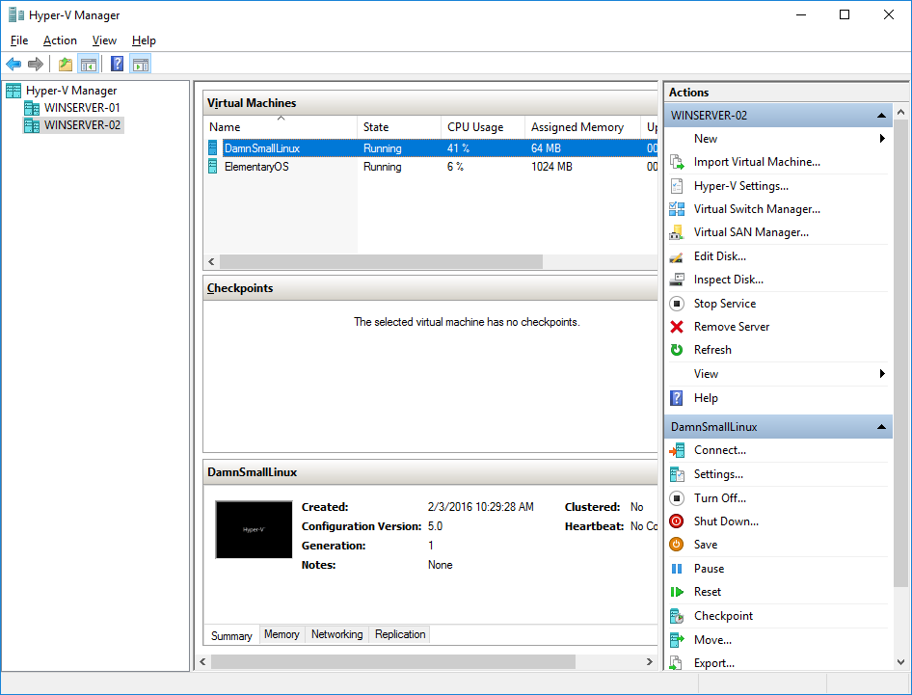

**Step 4. Configuring Hyper-V Replicas**

- *In* ***your report****, explain what a Hyper-V* ***Replica*** *is. What is the difference between VM migration and replica? How is the replica related to virtual machine redundancy and disaster recovery?*

**A: Hyper-V Replica is a free disaster recovery tool in Hyper-V that creates and maintains copies of Virtual machines, in the event of a catastrophic loss an administrator can failover to the replica VMs and provide business continuity.**

**It involves a primary host and a secondary host, a mechanism for creating application-consistent backups called a VSS writer creates a snapshots of the virtual machine (VM) on the primary host. The Replica function then copies the snapshot to the secondary host. This allows a data center administrator to have a standby server with copies of the VMs ready at a moment's notice. The tool also enables VM replication across the Internet using HTTP and a high-end PC as the secondary host. This feature provides administrators with an economical way to store VM copies safely off-site.**

**Hyper-V Replica provides asynchronous replication of the virtual hard disks of Hyper-V Replica virtual machines*.* Live migrating or storage migrating the primary virtual machine. You can perform live or storage migration of the primary virtual machine between hosts and between clusters with no effect on Hyper-V Replica. Storage migration on the replica virtual machine. This is fully supported and has no effect on Hyper-V Replica. Live migration on the replica virtual machine. Live migration is possible between nodes in the same cluster. However, if you live migrate outside of the cluster or between standalone hosts then replication will break.**

- Configure both **WinServer-01** and **WinServer-02** to be a Hyper-V replica server

o Use Kerberos (HTTP) for authentication.

o Enable replication from any authenticated server.

o Create and use folder C:\VMReplica as a default location to store replica files

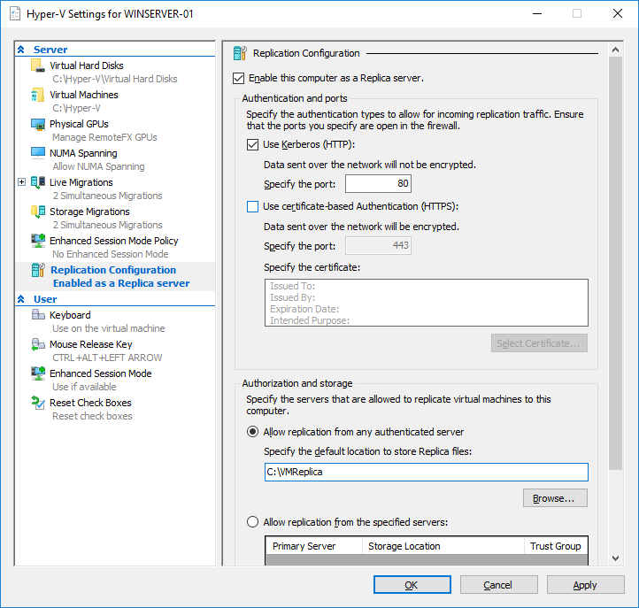

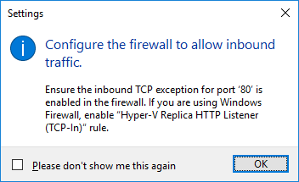

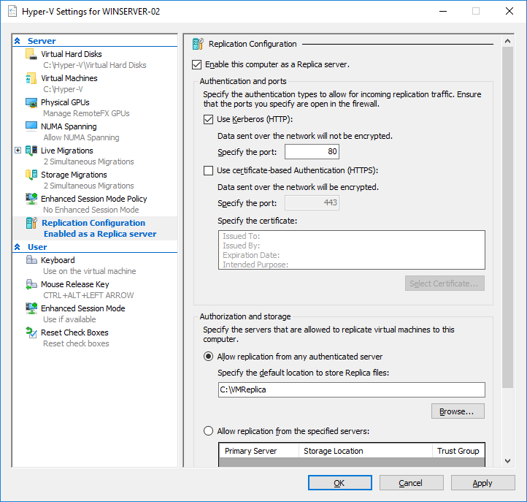



- Enable the firewall rule named **Hyper-V Replica HTTP Listener (TCP-In)** on both hosts.

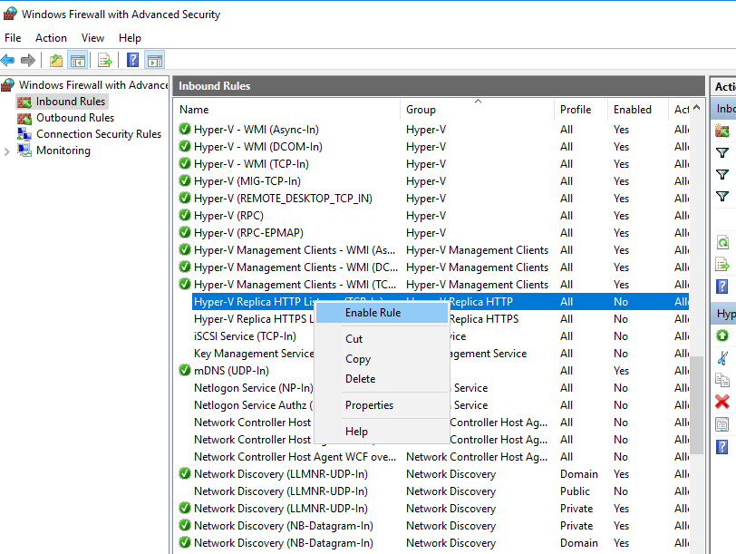

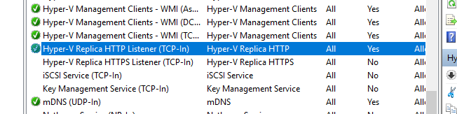

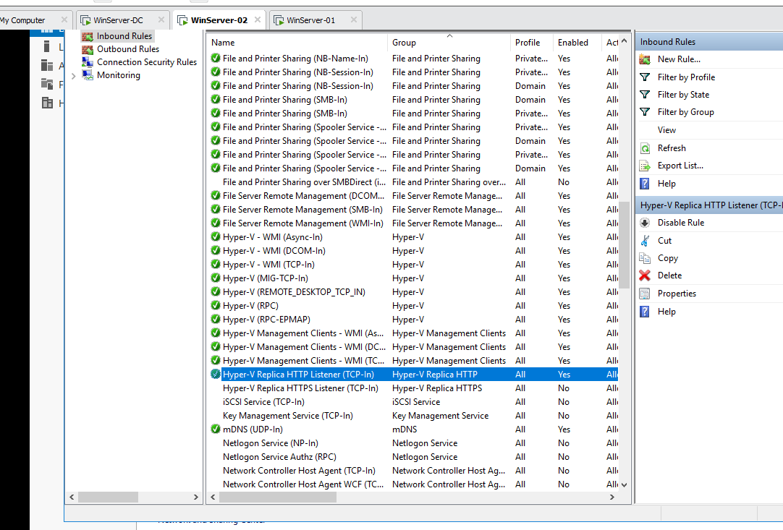

- In **WinServer-01 Hyper-V Manager**, enable replication for the **DamnSmallLinux** virtual machine (on **WinServer-02**).

o Use Kerberos (HTTP)

o Select to have only latest recovery point available.

o Start replication immediately.

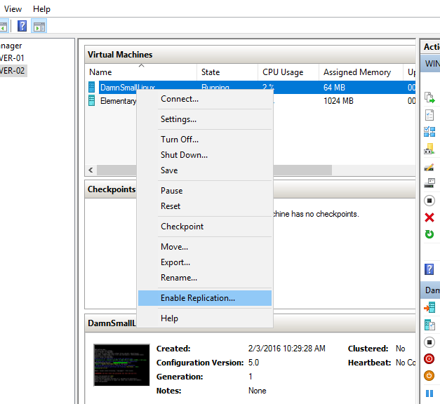

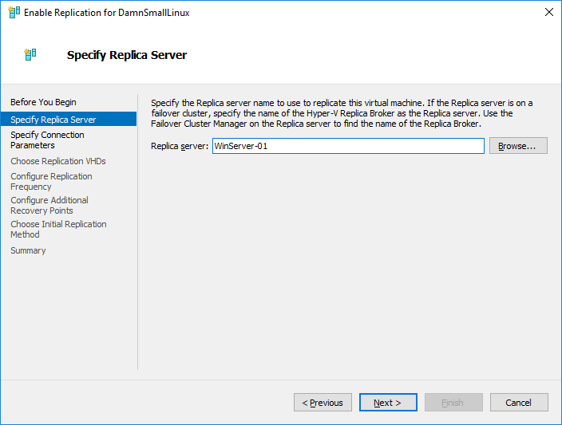

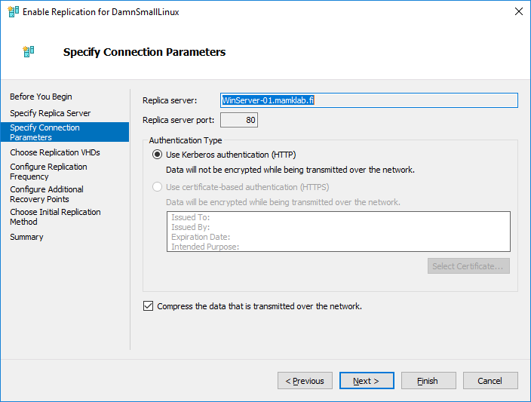

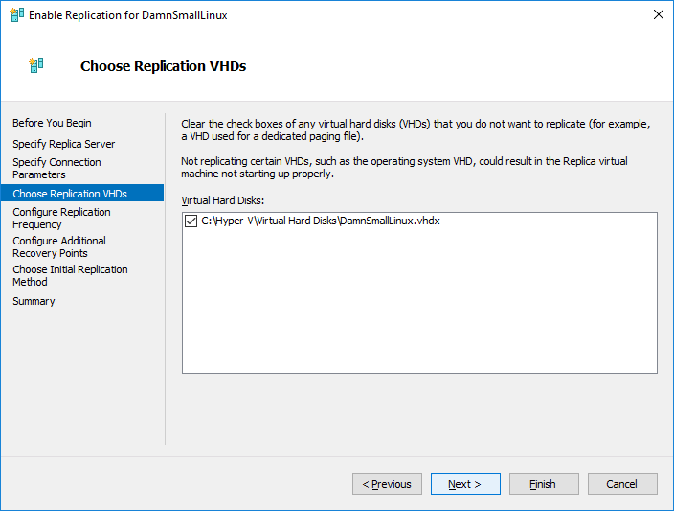

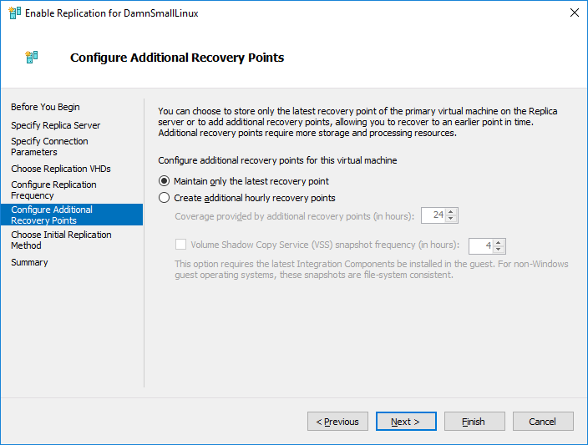

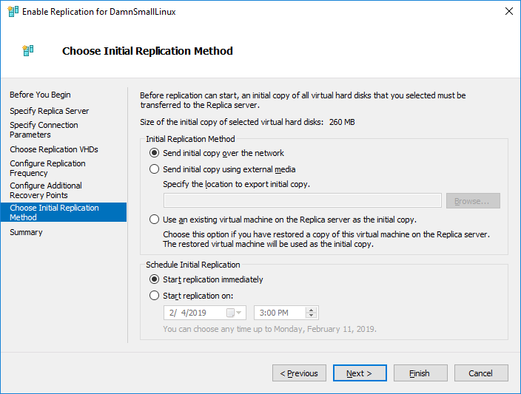

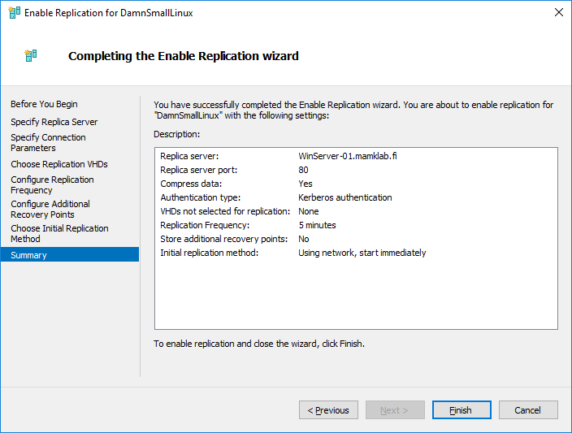

- Wait for the initial replication to finish and make sure that the **DamnSmallLinux** VM has appeared in **Hyper-V Manager** console on **WinServer-01**.

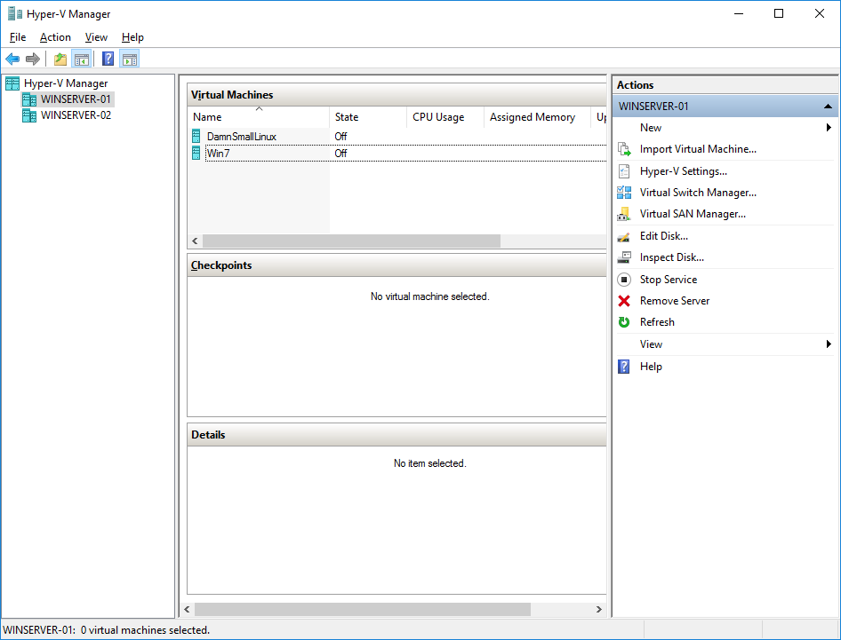

- Also check the replication state, health and the primary/secondary servers for the **DamnSmallLinux** VM.

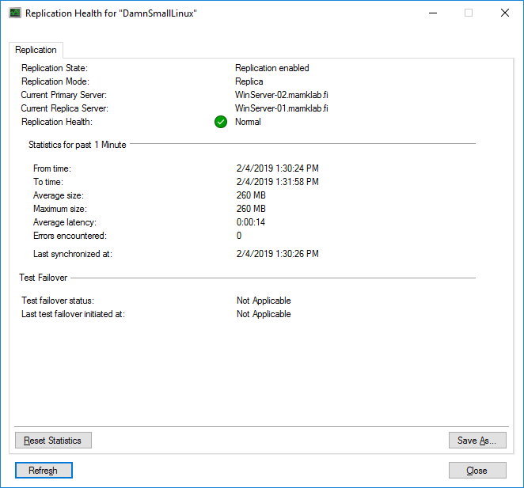

- On **WinServer-02**, perform a **planned failover** to **WinServer-01**

o Reverse the replication direction after failover to let the synchronization continue after the failover.

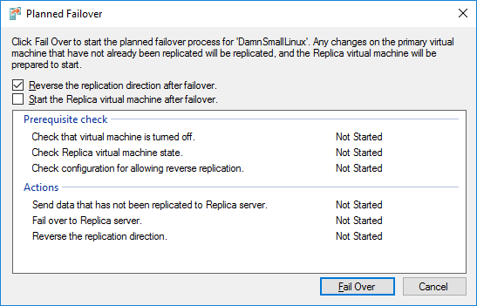

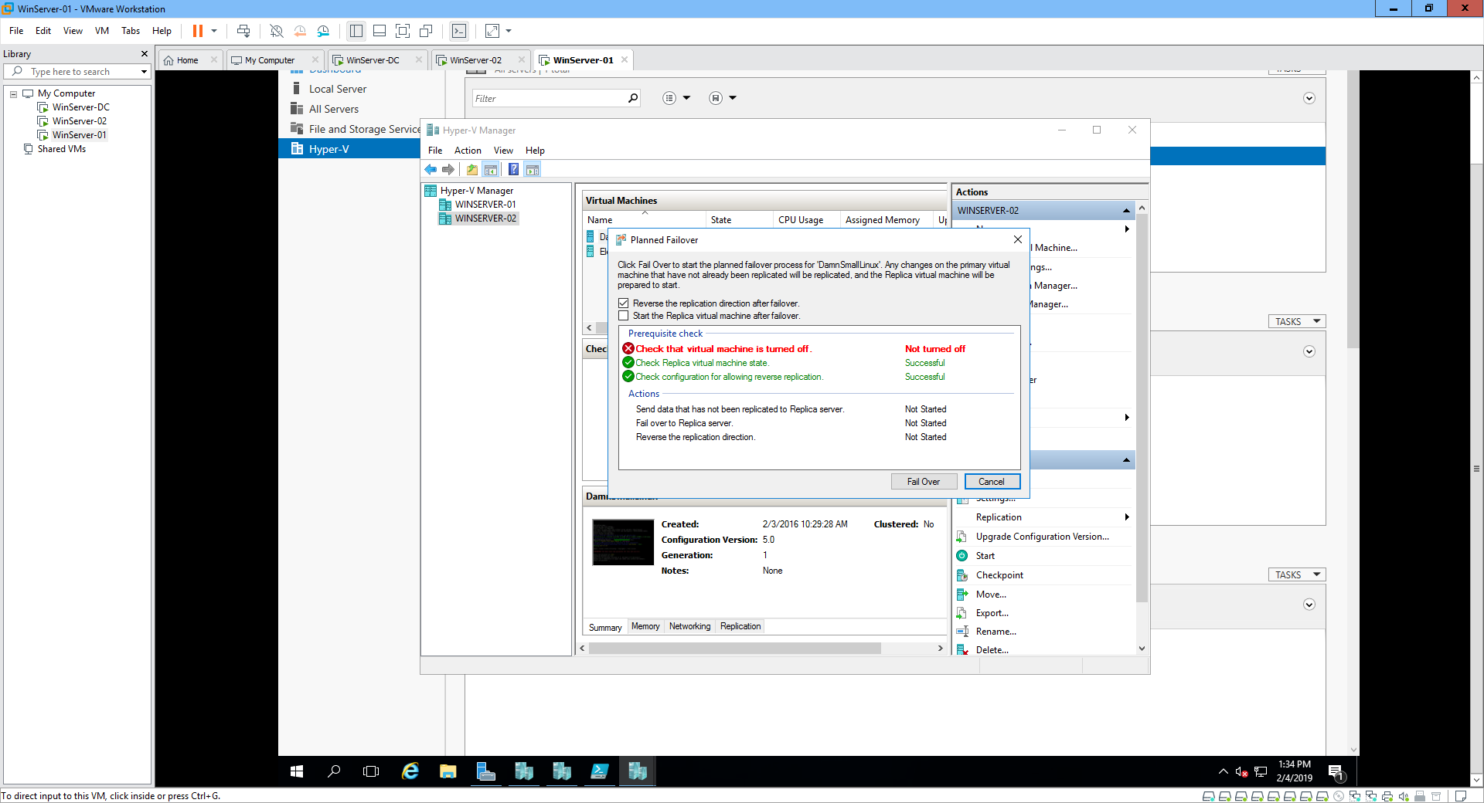

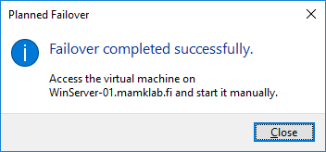

o *In* ***your report****, explain the procedure needed for the failover. Could you do the failover while the VM was running? After the failover, what is the* ***DamnSmallLinux*** *VM state in WinServer-01 and WinServer-02?*

**A: Click the VM - click on Reverse Replicate**, **once the job is complete, click the VM - In Failover, verify the failover direction (from secondary VMM cloud), and select the source and target locations. Initiate the failover. You can follow the failover progress on the Jobs tab, in the primary VMM cloud, check that the VM is available. If you want to start replicating the primary VM back to the secondary site again, click on Reverse Replicate**.

Finally, describe **in your report** your personal experiences about doing the lab and your experiences of working with the Hyper-V virtualization tools.

**A: Hyper-V let’s to create and run a software version of a computer (VMs) acts like a complete computer, running an operating system and programs, when the resources need computing, the VM give more flexibility and help to save time and money, they are more efficient way to use hardware than running one OS on physical hardware. Hyper-V runs each VM in own isolated space, so it allows to use more than one VM on the same hardware at the same time.**